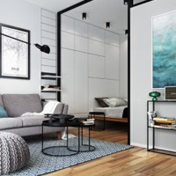

FOUR UNIT APARTMENT

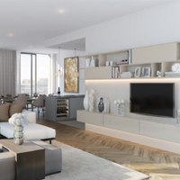 BUNGALOW

 6 UNIT APARTMENT

 2 UNIT APARTMENT

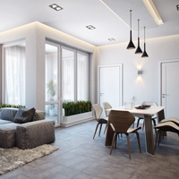 12 UNIT APARTMENT

 GOLD

 DIAMOND

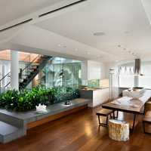 DUPLEX

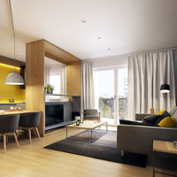8 UNIT APARTMENT

THIS OPTIONS ARE PICKED RANDOMNLY ON A DAILY BASICS, YOU ARE ABLE TO BUY ONE AT A TIME BUT CAN SELL ANY OF THEM IN UNITS I.E IF U HAVE 100 PIECES, YOU CAN SELL THE 100 AT ONCE BUT BUY 1 AT A TIME , YOU BUY FROM DAILY INVESTMENT BUT SELL THROUGH ASSESTS.

APPLICATION NEW CONTACTS:

CONTACT:

PHONE: (+234)9034960070

WEBSITE:

EMAIL: cashstreams1@yahoo.com

TWITTER: @ cashstreams1

FACEBOOK: cashstreams1

INSTAGRAM: cashstreams1

EMMA WASSUP , ONCE YOU HAVE INPUTED THIS TELL ME